THE 22nd International Symposium on Chirality
(Chirality 2010; ISCD-22)

Eiji Yashima¹, Kazuhiko Saigo²

¹ Department of Molecular Design and Engineering, Graduate School of Engineering, Nagoya University, Nagoya 464-8603, Japan
author@apchem.nagoya-u.ac.jp
²Department of Chemistry and Biotechnology, Graduate School of Engineering, The University of Tokyo, Tokyo 135-0064, Japan

The 22nd International Symposium on Chirality (Chirality 2010, ISCD-22) will take place at the Sapporo Convention Center in Sapporo, Japan, from July 12 to 15, 2010.
Chirality 2010 will be the 22nd in a series of annual international symposia devoted to all aspects of chirality in the life and natural sciences, with special emphasis on molecular chirality and stereochemistry. In addition to the traditional Chirality Medal Symposium, outstanding contributed talks, poster sessions, exhibition and other activities that over the years have made this the most important meeting in the field of chirality, we are planning some special emphases for the Sapporo meeting including three plenary speakers will present their latest research along with 26 invited speakers. The program will also include some 30 invited short talks and three poster sessions, which will allow students and others to highlight their recent work.

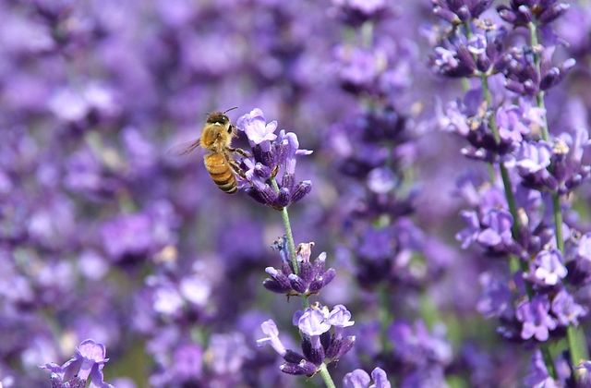

Figure 1. A honeybee with lavender flowers.

Follow these guidelines to write your 1-page abstract. SIZE: one white A4 page. MARGINS: 25 mm left, right, top, and bottom. TITLE: Centered, bold capital letters, Times New Roman 12 points. AUTHOR(S): Centered, presenting author underlined, Times New Roman 12 points. AFFILIATION(S) AND FULL ADDRESS (ES): Centered, italic, 11 point. In the case of different affiliations of the authors, specify with superscript 1, 2, etc. Include e-mail of corresponding author. MAIN TEXT: Times New Roman 12 points. Left and right justified. No indent. FIGURES: Located within the text. REFERENCES: Placed in square brackets [1, 2, ...] in the text and cited at the bottom of the abstract.
Abstract should be submitted in OFFICE WORD format and also in PDF.

[1] E. Yashima, K. Maeda, H. Iida, Y. Furusho, K. Nagai, Chem. Rev. 2009, 109, 6102.

